Investigative Report

Lane Dorscher
CYBR250-T301 Intro to Cyber Threats, Tech
Bellevue University
12/14/2025
Jason Kramer

Introduction
This investigative report examines the hardware, software, and security posture of a personal computer from a cybersecurity perspective. Every computer system leaves behind digital traces that reveal how it is configured, how it is used, and how effectively it is protected. By reviewing system specifications, installed software, and security practices, this report identifies strengths as well as areas that could be improved. The purpose of this investigation is to better understand the system’s digital footprint and to reflect on how security, privacy, and data protection practices affect everyday computer use.

Hardware Specifications
CPU
The system is powered by an AMD Ryzen 9 3600X 12-Core processor. The base clock speed is 3.79 GHz, with current operating speeds reaching approximately 4.15 GHz.
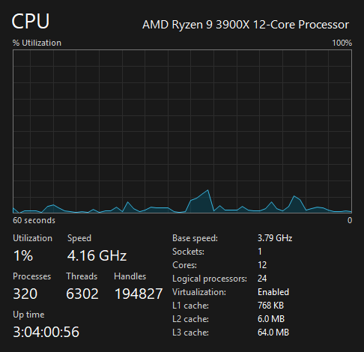

Disk Storage
The computer uses multiple storage devices. The primary drive is a Samsung 970 EVO 1TB NVMe solid-state drive, which hosts the operating system and core applications. Additional storage includes two SATA-connected hard drives: a 2TB ST2000DM001-1ER164 and a 2TB ST2000DM008-2FR102. In total, the system contains approximately 5TB of local storage.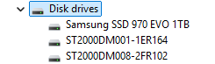

Audio Devices
Audio output is primarily handled through HyperX gaming headphones. The system does not use standalone desktop speakers; however, both the LG Ultrawide monitor and the AORUS AD27QD monitor include built-in audio capabilities. The motherboard’s Realtek audio drivers manage most audio input and output. Additional listed devices support Steam and Oculus streaming, and a USB 2.0 camera provides an integrated microphone.
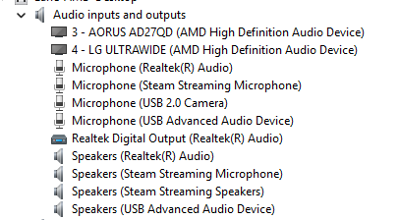

Input Devices
Primary input devices include a Logitech G910 keyboard and a Rosewill RGM-400 mouse. A USB 2.0 camera is used for video conferencing, and microphone input is typically handled through the HyperX headset.
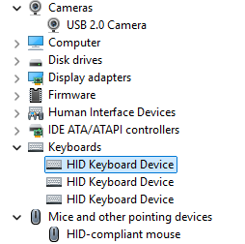
Output Devices
The system uses two 27-inch monitors, one of which is an ultrawide display. Audio output is normally routed through the headset, with monitor speakers used occasionally when necessary.
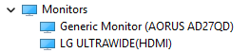

RAM
The system contains four 8GB RAM modules, totaling 32GB of memory. This configuration supports high-performance gaming, multitasking, and the use of multiple applications simultaneously.
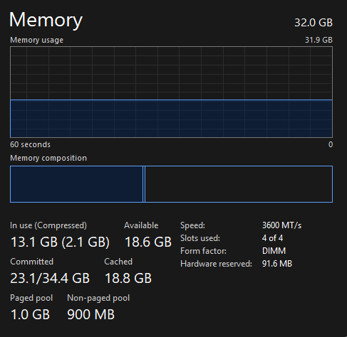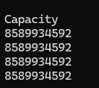

Software
Operating System
The computer was originally installed with Windows 10 and has since been upgraded to Windows 11. System information indicates Windows 11 as the operating system, though some version references still reflect Windows 10.
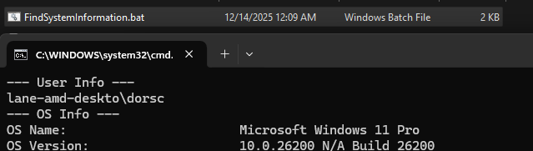
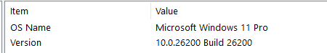
System Protection
System security currently relies on Windows Security, which provides antivirus protection and a built-in firewall. Modern web browsers such as Firefox also contribute additional protection by blocking malicious websites and scripts. A previously used NordVPN subscription has expired and is no longer active. The absence of a VPN reduces protection of the public IP address, particularly when accessing public networks.

System Protection
Backup Procedure
At present, there is no comprehensive system backup in place. Programming projects are partially protected through GitHub version control repositories; however, this does not serve as a full system backup. The lack of a backup strategy is primarily due to not taking the time to properly learn and implement one. A recent forced shutdown nearly resulted in significant data loss, highlighting the importance of maintaining reliable backups to prevent future issues.

Security and Privacy
Windows Security performs regular scans to detect potential threats, and built-in browser protections reduce exposure to malicious websites and tracking scripts. Firefox also includes DNS-based privacy features that enhance user protection. Implementing a VPN, ideally at the router level, would further improve security by protecting all connected devices on the home network.

Conclusion
This investigation demonstrates how easily system configuration details can be identified using built-in operating system tools. While the computer is equipped with strong hardware and basic security protections, the absence of a complete backup strategy represents a significant vulnerability. The recent shutdown incident emphasized the risks associated with inadequate data protection. Overall, this report highlights the importance of combining strong system security with reliable backup practices to ensure both data integrity and long-term system resilience.

References
System Information, Device Manager, and Task Manager
National Institute of Standards and Technology. (2020). Security and privacy controls for information systems and organizations. Retrieved from https://doi.org/10.6028/NIST.SP.800-53r5

